|  |  |
| --- | --- |
| Experiment Number:09 | **09** |
| **Title: Performing DHCP Configuration using cisco packet tracer.** |
| ▪ |  | |

**Second Year Advanced Computer Networking**

Objectives:

* **To learn how to Configure DHCP service on Cisco Packet Tracer.**

Theory

In this Experiment we will see how to configure a DHCP server both on a router and on a generic server in Cisco Packet Tracer.

1. **Steps to Configuring DHCP server on a Router.**

* **Step 1: Build the network topology:**

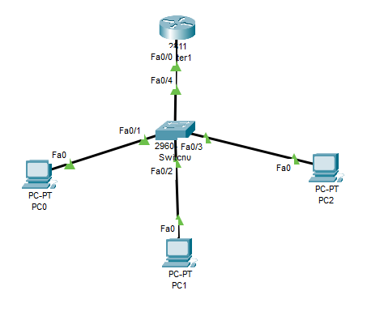

* **Step 2: On the router, configure interface fa0/0 to act as the default gateway for our LAN.**

*Router>enable*

*Router# config terminal*

*Router(config)#int fa0/0*

*Router(config-if) #ip add 192.168.125.254 255.255.255.0*

*Router(config-if) #no shutdown*

*Router(config-if) #exit*

* **Step 3: Define a DHCP pool of IP addresses,** **a Default gateway, a DNS Server.**

*Router(config)#*

*Router(config)#ip dhcp pool MY_LAN*

*Router(dhcp-config)#network 192.168.125.0 255.255.255.0*

*Router(dhcp-config)#default-router 192.168.125.254*

*Router(dhcp-config)#dns-server 192.168.125.1*

* **Step 4: Exclude reserve addresses**

*Router(config)#ip dhcp excluded-address 192.168.125.1 192.168.125.2*

Use ip dhcp excluded-address command to configure the router to exclude addresses 192.168.125.1 and 192.168.125.10

* **Step 5: Setup DHCP Client Machine**

Now go to every PC and on their IP configuration tabs, enable DHCP. Every PC should be able to obtain an IP address, default gateway and DNS server

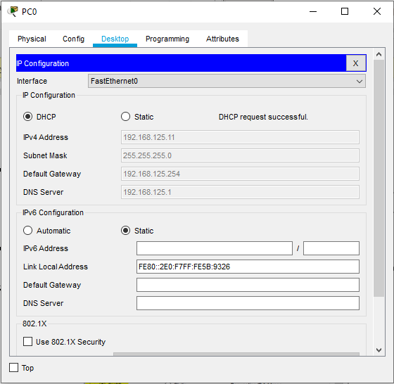



1. **Steps to Configure DHCP service on a generic server in Packet Tracer.**

* **Step 1: Build the network topology:**

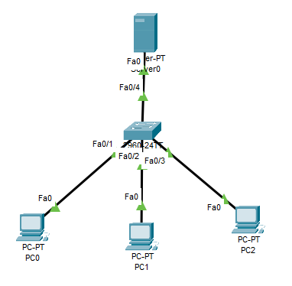

* **Steps 2: Configure static IP address on the server (192.168.125.2/24).**
* **Steps 3: Now configure DHCP service on the generic server.**

To do this, click on the server, then click on Services tab. You will pick DHCP on the menu. Then proceed to define the DHCP network parameters as follows:

Pool name: MY_CSE_DHCP

Default Gateway: 192.168.125.254

DNS Server: 192.168.125.1

Start IP Address: 192.168.125.10

Subnet Mask: 255.255.255.0

Maximum Number of users: 254

Click on add then Save.

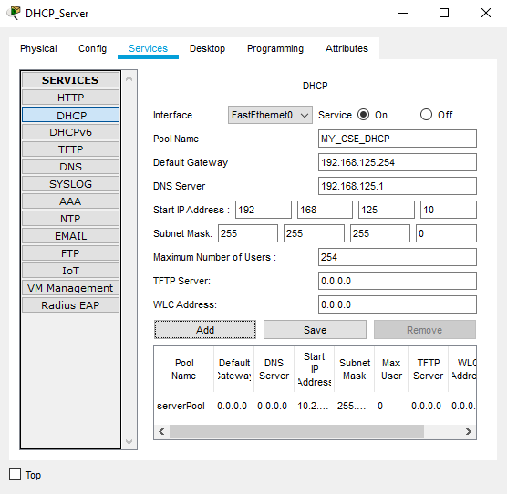

Finally, enable DHCP configuration on each PC. The remaining PCs should get automatically configured.